Grant Purpose
The purpose of this program is to consider providing grant funds to non-profit agencies in financial support of on-going projects and services. These grants are funded out of the County’s Contributions to Outside Agencies’ budget. The application is for programs/projects that are not health and human services related.

Timeline
Funding for this category will be considered during the County’s annual budget hearings in June 2023.

The deadline for submittal of applications is July 14, 2023. Completed electronic applications will be accepted until 5 p.m. on that day. The applicants will be evaluated shortly after receipt.

NOTE:

- Grant applications should be one complete PDF document.

Application Naming Convention:
your organization Other Agency grant 23-24, e.g., Coastal San Luis RCD Other Agency grant 23-24

- No paper copies of the grant application will be accepted.
- Incomplete electronic submittals will not be accepted.

Review and Selection Criteria
Applications will be reviewed and ranked according to how well it addresses the following:
- Local Need;
- Identified funding sources showing the ability to leverage the other funds;
- Organizational ability to leverage the grant funds (if applicable);
- Requirement to obtain a funding public match (if applicable);
- Projected program/project goals, results, and outputs/outcomes;
- Projected program results, outputs/outcomes from prior year’s grant (if applicable);
- Program cost compared with number of people served;
- Geographic distribution of services;
- Percentage of requested funding being used for direct services;
- Program/project sustainability with funds granted;
- Collaboration with other community-based agencies and County departments (if applicable).

General Application Information
Programs/projects must be carried out in San Luis Obispo County and serve only San Luis Obispo County residents. Applicants must offer their services to all residents of San Luis Obispo County, regardless of political or religious opinions or affiliations, age, sex, race, color, national origin, marital status, disability, sexual orientation.

All costs associated with the preparation and submission of this application will be borne by the applicant. All applications become the property of the County of San Luis Obispo and will become public information after the submission deadline.

Information Submission

The application should be submitted, as one electronic PDF (see Exhibit 2), in the following order:

PROPOSALS SHOULD CONTAIN THE FOLLOWING:

COVER SHEET

Application must have a COVER SHEET which clearly identifies:

- Project Title
- Organization/Agency Name
- Executive Director and/or Program Contact Person
- Address
- Phone number
- E-mail address
- Amount of funds being requested
- If applicable, funds received in the prior year (or most recent fiscal year when funds were received)
- A brief (50 words or less) description of proposed project

PROGRAM/PROJECT INFORMATION:

The application must contain the following information:

1. Briefly describe your organization and its mission.
2. Summarize your program/project by providing a brief description.
3. Describe:
- How this program or service is beneficial to County residents?
- How was the local need for this project/program determined?
- How does your organization collaborate with County departments or community organizations in providing the identified program or service?
- Your organization’s ability to build and maintain a high level of collaboration with other community organizations or resources providing the same type of program or service.
- How will your organization use and leverage the grant funds?
- What type of experience and knowledge does your organization’s staff have that would demonstrate knowledge and understanding of the program or services.
- Describe your organization’s capacity to successfully carry out the proposed program or service (i.e., past performance and history of the organization will be considered in order to assess the organization's prospects for achieving its goals and objectives).

SCOPE OF WORK OR WORK PLAN

The following information should be provided in the format shown below.

FY 2023-24 Scope of Work or Work Plan:

Organization scope of work should answer these questions:

  - What is the program/project goals?
  - How will those goals be achieved including time frame?
  - What is your evaluation mythology for measuring results?

FY 2022-23 Program Results:

If the applicant has received County funding in prior years, please describe the achievements of the FY 2022-23 to date.

EXHIBIT A
SCOPE OF WORK/WORK PLAN FORMAT

Requested Grant Funds in Fiscal Year 2023-24

Program/Project Summary: _______________________________________________

Goal/Objective  (refer to 1.A above) | Major Tasks  (in order to achieve goal)  (refer to 1.B above) | Timeline | Evaluation methodology  (refer to 1.C above)
Program/Project OUTPUTS
Program/Project OUTCOMES

Grant Funds Received in Fiscal Year 2022-23 (if applicable)

Program/Project Summary: _______________________________________________

Goal/Objective  (refer to 1.A above) | Major Tasks  (in order to achieve goal)  (refer to 1.B above) | Timeline | Evaluation Mythology  (refer to 1.C above)
Program/Project OUTPUTS
Program/Project OUTCOMES

SCOPE OF WORK/WORK PLAN
EXAMPLE

RESULTS:

A meaningful, measurable result will demonstrate the difference the proposed project makes, or is intended to make, in the lives of the people receiving the service.

OUTPUTS: are measurements that show the amount of work performed or services received - e.g., number of patients treated, number of meals served, number of childcare slots created, etc.

Output Measures: 500 people will participate in health screening clinics and receive referrals for follow-up when indicated.

75 people will be enrolled in the Healthy Families MediCal program to improve utilization of health services.

XX number of meals will be served to seniors during the year.

OUTCOMES: are measurements that show the quality of performance and answer the question: who is better off by doing this project? Here are some examples:

Outcome Measures: At least XX% of smokers who participate in services will successfully quit using tobacco.

XX% of clients that receive substance abuse treatment services and are drug and alcohol free one year later.

XX% of program participants in the prevention program will demonstrate their commitment to an alcohol and drug-free lifestyle.

PROGRAM/PROJECT BUDGET

- Provide a program/project budget that includes the following information (format attached):

- A description of all sources of funding for the proposed program/project, including funding not yet secured or funding from County sources (if applicable).

- Identifies the part of the proposed program/project the requested funds will be used for.

- A one (1) page budget narrative that:

- Describes individual line items pertaining to “in-kind” funding or funding sources not yet secured.

- If the requested funds are to be used for a public match that is required by another funding source, identify:

  - the other funding source
  - amount of match required
  - type of match (e.g., 1:1, mandatory public funds only, combination of public/private funds, in-kind)

- If your organization is submitting one application for multi-programs/projects, please submit a separate budget for each program/project request.

- A current year operating statement for your organization.

PROGRAM BUDGET REQUEST FORM

 | Project  Expense | Grant Budget  Requested | Other Funding Available*  Amount & source
- PERSONNEL EXPENSES
(associated with the proposed project)

Subtotal – Personnel Expenses
- OPERATING EXPENSES
(associated with the proposed project)

Subtotal – Operating Expenses
- INDIRECT @_______ OF PERSONNEL

Total Grant Project Expenses

*List in this column all agency funds available to support the project. Indicate with a “@” next to the amount that are in-kind and a “NS” for those not yet secured.

GENERAL SUBMISSION INFORMATION

- All applications should be clear, concise, and complete. No additional information will be accepted past the July 14, 2023, deadline unless specifically requested by the County.

- All applications should be one complete PDF electronic submittal, including the information requested in #3 below. There should not be any separate attachments as part of the grant submittal. Postmarks and hand delivered applications will not be accepted.

Application Naming Convention:
your organization Other Agency grant 23-24, e.g., Coastal San Luis RCD Other Agency grant 23-24

- All applications should also include the following:

  - Organizational operating budget.
  - Key program personnel (include a short description of their background.)
  - Board of Directors of your organization and relevant advisory boards (please include member affiliations.)
  - Adopted organization policy or statement on inclusion, diversity, or affirmative action.
  - Tax-exempt status documentation, e.g., IRS determination letter.
  - A copy (each) of the current status of non-profit organization from Secretary of State and Attorney General Office. These documents can be accessed at the specific agency’s web site at Secretary of State and Attorney General’s Office.

See Exhibit 1 for examples of these status reports. Please do not send your organization’s Statement of Information.

Grant applications from organizations that do not include this documentation or whose non-profit status is “inactive“ or “delinquent” will not be accepted. This requirement does not apply to grant applications from public agency such as a school district, County agency or department.

- Please DO NOT include electronic attachments such as letters of references, brochures, or flyers. If necessary, this information will be requested later.

- All costs associated with the preparation and submission of this application will be borne by the applicant.

- All applications become the property of the County of San Luis Obispo and will become public information after the submission deadline.

- Applications should be submitted electronically (PDF) only format to the following address:
AD_Admin_Grants@co.slo.ca.us

Any questions regarding the RFA or process should be directed to Olena Nagorna of the County Administrative Office at (805) 781-5496.

EXHIBIT #1

SECRETARY OF STATE EXAMPLE
Please include your organization’s information in your electronic submittal.

Search Screen:
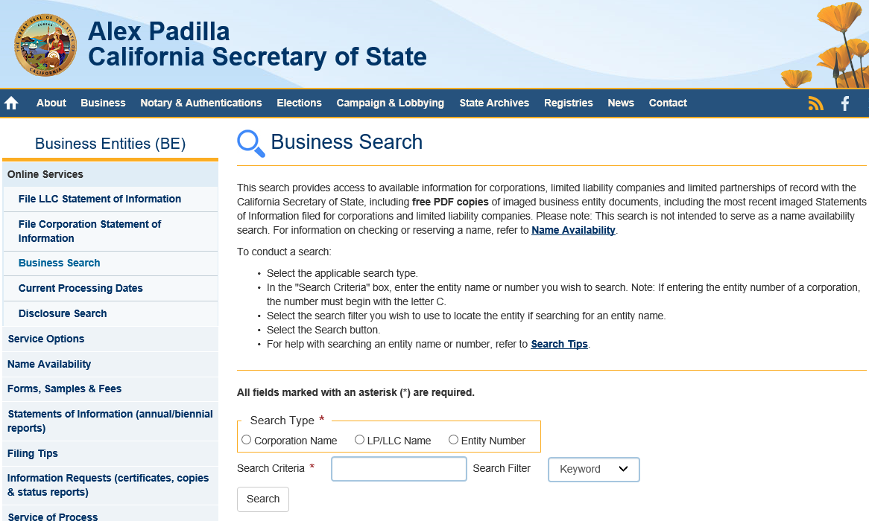

Provide a copy of either page:

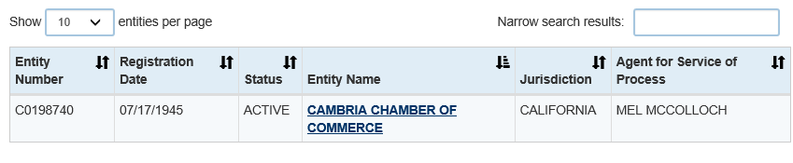

or

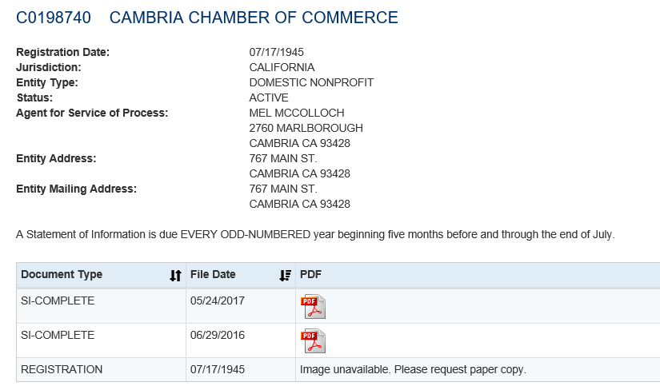

Department of Justice/Office of Attorney General example:

Search Screen:
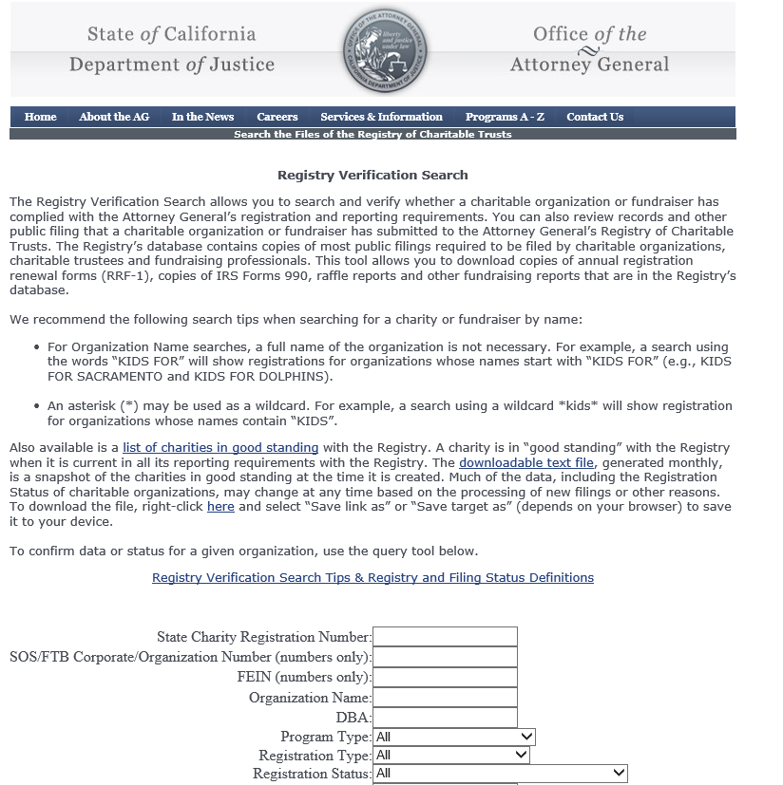

Provide a copy of either page:

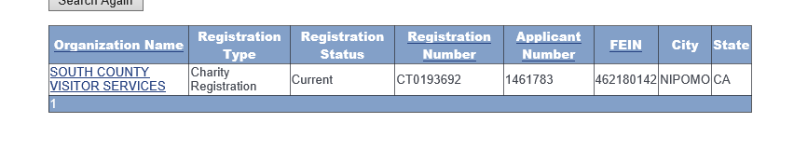
or

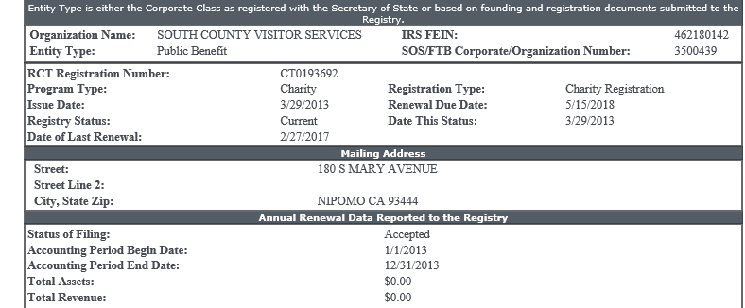

Exhibit #2

ELECTRIONIC APPLICATION PDF should contain the following:

- Cover sheet
- Program/project information – maximum 5 pages
- Scope of work using format shown in the RFA
  - FY 2023-24
  - FY 2022-23 results to date
- Program/Project budget using format shown in RFA
- Organizational operational budget
- Key program personnel
- Board of Directors
- Adopted organization policy or statement on inclusion, diversity, or affirmative action
- Tax-exemption status documentation, e.g., IRS determination letter
- Status of non-profit from both the California Secretary of State and Attorney’s General Office

